**Illness and Leeway**

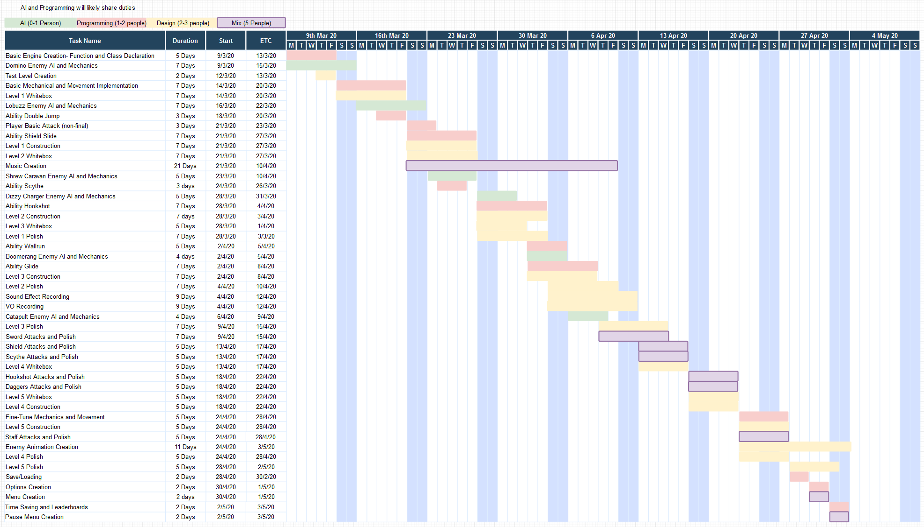

Figure 1 – Gantt Chart

*A higher quality version of this chart can be found alongside this document.*

When designating roles, it is important to consider the capabilities of each person working on the project, and their skills. It is also important to consider time management and ensuring that each task will be completed. Our group is fortunate, as we have programmers that can specialise in AI and do general programming work, as well as a programmer who can model and produce high-quality artwork. Because of this, it is important to ensure we do not have more than 3 programming or designing tasks active at once time, assuming that the team will be able to assist with multiple elements of multiple tasks (hence why there are occasionally 6 tasks active at once for 5 people)